**Sustainability, replication and exploitation of project results**

**CALL FOR INTEREST**

Deadline 28th February, 2025

Are you involved in the management of natural coastal areas threatened by subsidence, coastal erosion, flood risk, and loss of habitat and biodiversity?

Do you find NBS (Nature-Based Solutions) important and useful?

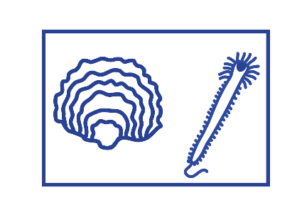

**“CONTACT US TO SHARE EXPERIENCE AND KNOWLEDGE”**

**“VISIT LIFE NATUREEF SITE”**

**“WORKING TOGETHER TO CONTRIBUTE TO THE PROTECTION**

**OF HABITATS AND COASTAL BIODIVERSITY.”**

The Life NatuReef project involves identifying possible sites where to propose replication and exploitation of project results.

The strategy for replication and exploitation of project results consists of the following steps:

* Research possible administrations and agencies dealing with natural coastal sites threatened by the same issues addressed by NatuReef;
* Offering guidelines and a toolkit to administrations of different sites for effective exploitation of NatuReef results;
* Support new partners to replicate the project with appropriate adaptations to site characteristics;
* Offer free advice to possible new partners in replicating the project to help them solve problems they may encounter;
* Create a BIOGENICREEF committee among partners willing to adopt these guidelines, sharing different views and experiences.

**WHO CAN APPLY?**

The “Call for Interest” is addressed to all agencies and administrations that manage coastal natural areas that have similar natural features with the NatuReef project area and face shared threats, including: subsidence, coastal erosion, flooding, habitat loss and biodiversity

**HOW TO APPLY?**

Fill out the attached APPLICATION FORM and send it by email to [parcodeltapo@cert.parcodeltapo.it](mailto:parcodeltapo@cert.parcodeltapo.it) by the date 28th February, 2025

**CALENDAR**

|  |  |
| --- | --- |
| Opening Applications | 2nd December, 2024 |
| Application Deadline | 28th February, 2025 |

**LIFE NATUREEF PROJECT**

LIFE NatuReef is a European project to restore ancient oyster and sabellaria reefs at the mouth of Bevano river. An ambitious initiative aimed at restoring and enhancing marine and coastal habitats.

These reefs are natural “bioconstructions” that provide a range of ecosystem goods and services, including restoration of underwater habitats, enhancement of biodiversity, and protection of coastal habitats from storm surges and erosion processes, with a view to combating and adapting to climate change.

The project is an important initiative for environmental conservation and sustainable development and represents a laboratory of “best practices” applied for the first time in the Adriatic Sea.

**LIFE NatuReef is nature repairing and regenerating**

**Objectives:**

1. **Creating an oyster reef**

LIFE NatuReef will create a submerged native oyster reef of about 4,000 square meters near and parallel to the beach. Oyster reefs provide elective habitats for various marine species, contribute to improved water quality and shoreline protection.

1. **Stimulating the development of sabellariids worms**

Sabellaria are small worms that can create submerged reefs by aggregating sap. With small transplants, their growth will be stimulated at the base of oyster reefs, thus playing a crucial role in consolidating structures and increasing biodiversity.

1. **Enhancing marine biodiversity**

The goal is to increase the number of marine species, including algae, invertebrates and fish, providing an ideal place for the reproduction and protection of juveniles and repopulating the surrounding sea.

1. **Protect coastal habitats**

The project proposes a nature-based solution to protect and restore marine and coastal habitats, creating resilient and resistant marine and coastal habitats and communities to climate change.

1. **Promote the conservation of protected fauna and flora**

By creating a high-biodiversity habitat and protecting the coast, the marine and coastal protected species found in this oasis will be better protected.

1. **Increasing public awareness**

Educating and raising public awareness about the importance of restoring biogenic reefs as a nature-based solution for coastal defence and enhancing marine biodiversity is the first step toward a paradigm shift: protecting coasts by restoring natural environments, no longer by creating artificial barriers to the sea.

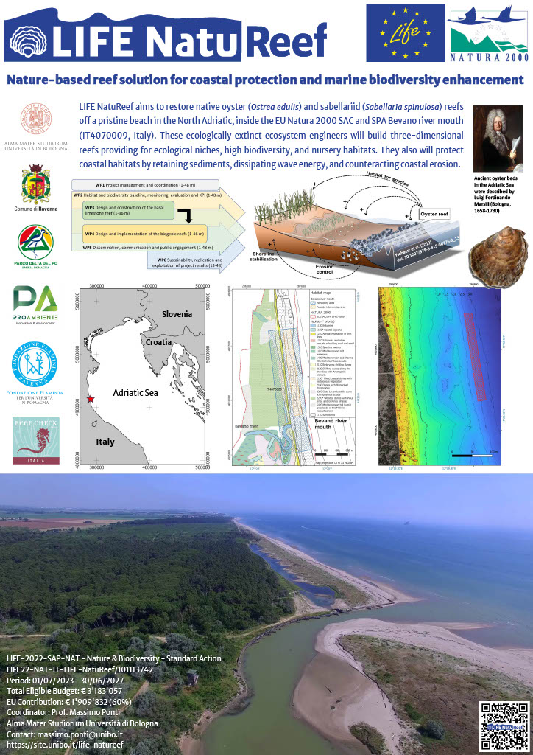

**Sustainability, replication and exploitation of project results**



**APPLICATION FORM**

|  |  |
| --- | --- |
| * **Name** of **site** * **Protected area (if any)** * **Natura 2000 site (if any)** * **Name** of the **managing agency** * Brief description of the main Habitats present with characteristic **Flora** and **Fauna** |  |
| What are the main **pressures** and **threats** affecting the site and what are the ecological restoration needs? |  |
| What NatuReef project **actions/methods** have the most potential to contribute to the needs of the site? |  |
| Contact person data:   * Entity of affiliation * Role within the institution * Email contacts * Phone contacts |  |
| …………………… |  |



**INSERT CARTOGRAPHIC IMAGE**

**(Google Maps, Google Earth, Ecc..)**

**OF THE POSSIBLE REPLICATION SITE**